1. Success add employee data & add employee account

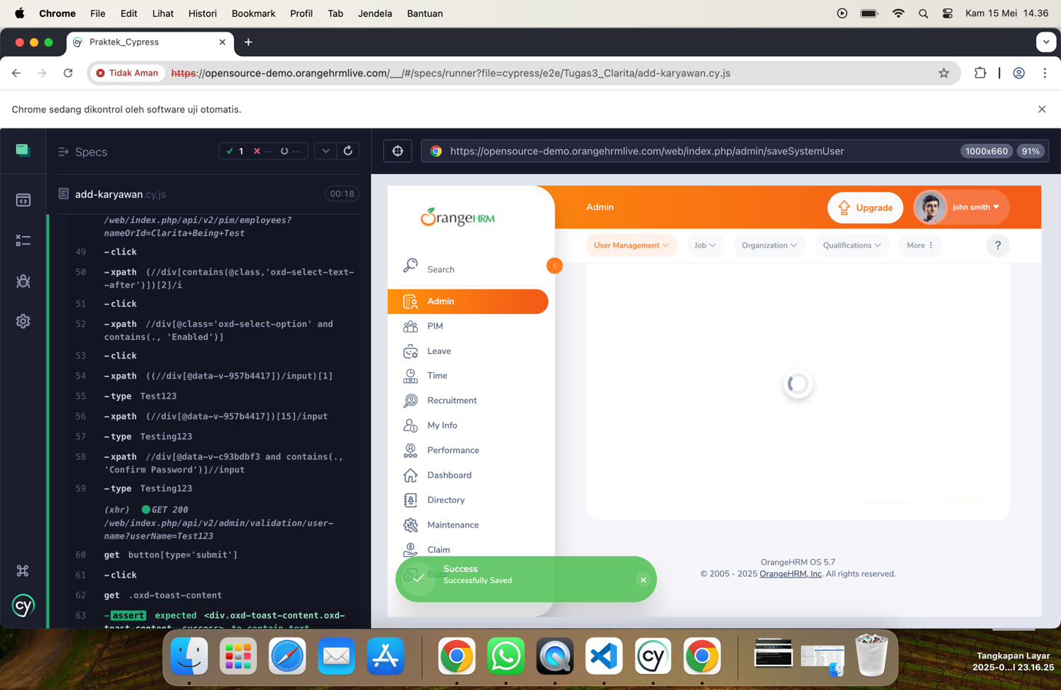

1. Success add entitlement employee

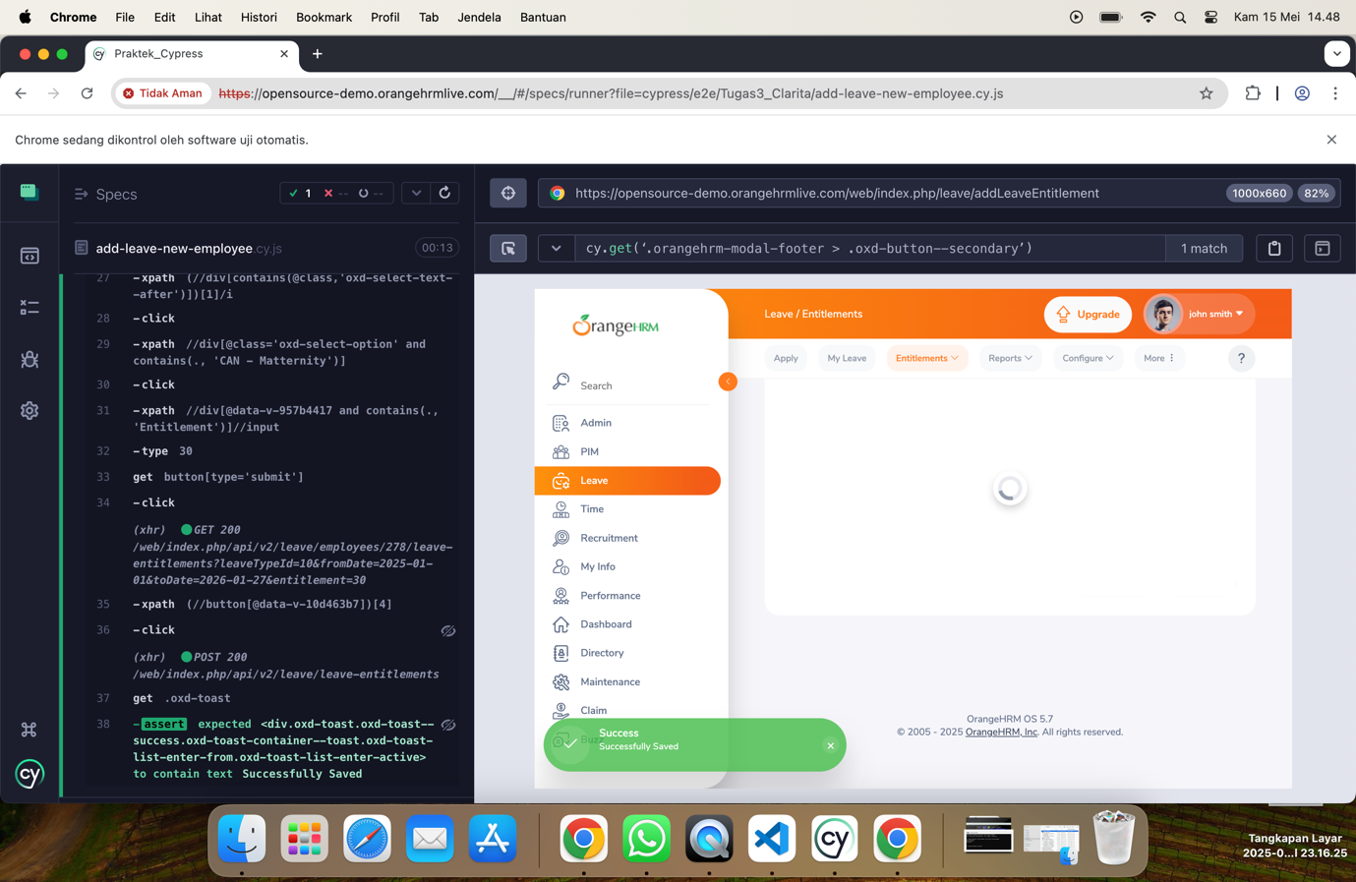

1. Success apply & approve leave